OPENING CORRIDORS FOR YOUTH ENGAGEMENT WITH NATURE
IN SHELBY COUNTY, TENNESSEE

By
Lilien Helene Ploderer

A Professional Paper
Requirements for the Degree of
Master of Arts

Major: Earth Sciences

The University of Memphis
May 2021
Abstract
Community redevelopment begins with the land and the way it is being used. It begins with the largest abandoned spaces and trickles down to every boarded-up home. This paper discusses the many issues surrounding urban blight, how near youth in Shelby County are to blight and why urban green spaces are the highest and best use for any larger blighted sites within a half mile to neighborhoods and schools. I am identifying large-scale blight sites in Shelby County, TN – particularly 1-75 acres within a half mile proximity to SC Schools (Elementary-High) to bring attention to needed remediation and the opening of new corridors for youth-to-nature connection. The paper includes: Mapping of youth populations, all K-12 School locations across Shelby County and large-scale blight patterns. Prioritizing youth’s connection to nature – utilization of parks, greenways and greenspaces. Understanding youths’ disconnect when surrounded by blight, the negative impacts of blight. Bringing awareness to needed reconnection with nature, finding areas for potential remediation. Encouraging the opening of new corridors in future urban planning.

Keywords:
Large-Scale Blight, Greenspaces, Youth Population, Schools, Nature Connection, Barriers, Remediation

Introduction
Academic achievement, community health, and environmental benefits have been linked to greenspace accessibility in society, neighborhoods, and especially in youths’ surroundings, such as school. On the other hand, business vacancy and abandoned properties considered “urban blight,” have been linked to academic failure, community stressors such as high crime, and environmental degradation (Heckert & Mennis, 2012). As many cities face challenges associated with land use, aging infrastructure and mismanagement, the highest and best use for blight in many cases is greenspace. “Green space is an area of grass, trees, or other vegetation set apart for recreational or aesthetic purposes in an otherwise urban environment” (Oxford, 2021). Though often overlooked, a city’s park and recreational system is a tool for sustainability, resiliency, and liveability (Barth, 2020), and offers a strategy to combat larger blighted spaces. Neighborhood enhancement includes the establishment of resources, commodities, and elimination of pollution, which greenspaces can provide. Recent news reports state Memphis needs a “new strategy for fighting blight” (Fox, 2020). While there has been a great push for neighborhood improvement since 2016, thousands of blighted properties continue to exist within communities, making local youth populations vulnerable to experiencing it. Advancements in GIS have allowed for more in-depth analysis of a place, however there are limited studies available on the whereabouts or impacts of blight in regards to youth populations in Shelby County. Furthermore, there is no accurate map of the larger scale blight, though mapping of housing and commercial blight has been attempted by the Bluff City Snapshot project (2020). While surveying properties myself, I took photographs of blight and aerial shots using Google Earth to include in this study.
The goal is to identify barriers causing youth-nature disengagement and suggest where to open more connecting corridors for youth. I use GIS and current Memphis GreenPrint plan mapping of proposed greenways to assess corridors that could be opened to better connect youth to nature. For locating where in Shelby County youth are more disconnected, the variables: youth population density, park presence, blight presence, school presence, walkability, crime rates, vacant housing units, proximity to pollution, and poverty levels, are investigated as potential barriers at the neighborhood code, zip code and housing district level. Areas that would most benefit from large-scale blight remediation to greenspace can then be distinguished. It is expected that the results will shed light on aspects of the built environment by exposing large blighted spaces nearest to youth and their schools, and inspiring future development of greenspaces in these areas.
Urban development strives to achieve comfort and convenience in our daily lives. Though industrialized civilization has undoubtedly altered landscapes and distanced people from the outdoors, we continue to cherish green spaces and use them as amenities, i.e. parks, playgrounds, urban gardens. In our efforts to design cities, we may not have expected that what we build could one day lead to abandonment, decay and negative social outcomes, however depending on land use management practices, with urban development comes urban blight - the unavoidable deterioration of the built environment. While development and infrastructure are some of humanity’s greatest feats, redevelopment of previously used land continuously challenges our ingenuity. Inability to manage abandoned properties from small to large, makes areas of populations vulnerable to experiencing negative social outcomes, i.e. crime, poverty, detrimental to neighborhoods and generational success. Blighted spaces are known to degrade communities but blight also creates barriers to nature-engagement and poses threats to the environment. Large areas require economical solutions, but remediation through greening is a sustainable option that is gaining popularity in regional planning. A new approach to a parks and recreation system that includes large-scale blight, could provide a framework for future open space planning.
With our ability to design cities, humans can also create many of their own social outcomes, since our built environment has an influence on behavioral patterns. According to Borden (2007), the built environment is a driving indicator for the manifestation of vulnerability. Populations most vulnerable to experiencing negative social outcomes, i.e. crime, littering, poverty, are likely place-based and the result of urban design features such as zoning and greenspace systems. Additionally, greenspaces exercise a different and greater influence on the progress of a city than any other public work in its urban structure (Barth, 2020). That is why greenspaces and techniques such as phytoremediation offer a means to mitigate many of the negative social outcomes blight has produced. Efforts to make life more comfortable and convenient have come full circle, as modern urban development and planning prioritizes greenspace connection and “design with nature” (Ian McHarg, 1969) in American cities - yet Shelby County is held back by high amounts of blight. Parks and recreation systems planning has become more complex in response to public needs (Barth, 2020), proving to be the key factor in revitalization. Shelby County’s current systematic approach to restoring abandoned spaces is slowly making progress, and this paper is a part of that movement. I prioritize the remediation of spaces near youth by assessing the impact of large blighted spaces, while asking how they could be incorporated as greenspaces, and open new corridors to existing greenways.
Connectedness to nature is desirable for families and becoming more apparent in the design and planning of suburbs across the study area. However, as more is built up in sprawling suburbs, other parts have been left behind, and as the times change, so do routes, neighborhoods, job opportunities, and industries. This can be seen in Memphis, as eastward development left inner city neighborhoods with hundreds of abandoned properties and unused space. Often large buildings are abandoned where manufacturing jobs once were located, and if the land is owned by an old company it can take decades for anyone to take responsibility, restore or remove the blighted space. The current system for blight remediation is complicated and slow. Building seems to be easier and happens so fast - what really poses challenges is the abandonment of the already built. Not only do abandoned structures pose threats to the natural environment, but they have been proven to degrade the lives of people living near it. Yet life goes on, as comfortable as possible with the pollution, poverty, crime, and illness that accompanies the presence of blight. Tall grass and overgrown shrubs become nuisances harboring fleas and mosquitos, broken windows have an effect on crime, per James Q. Wilson and George Kelling (1982). But most devastatingly, new generations grow up in built environments that have so many abandoned homes and buildings that it becomes a part of the landscape, creating huge barriers to nature connection in a healthy environment. Memphis of Shelby County, TN is only a little over 200 years old, yet the city has thousands of blighted properties. Corridors connecting locals to existing greenways have been expanding along old railway lines since 2010.
Current patterns of large-scale blight (1-75 acres) exist in the placement of abandoned sites along railways due to Memphis’ history as a manufacturing and transportation hub. Some sites are over 100 acres large and were included if they contained abandoned industrial or commercial structures. Old railways have since been turned into greenways and greenlines for walking and bicycling, which means there are possibilities for similar developments. What existing parks and greenways/greenlines Shelby County does have, such as Wolf River Greenway, Riverfront Greenbelt, Overton Park, Shelby Farms Park, are in use year round by people of all ages, providing value to the surrounding neighborhoods and schools.
In other cities different systems have been established to handle blight more efficiently and effectively. For example: “Vacant lots are abandoned parcels of open land with no buildings on them. Philadelphia and the Pennsylvania Horticultural Society (PHS) used the city’s anti-blight ordinance to identify and remediate vacant lots. Vacant lots with illegal dumping, untended vegetation above a certain height, excess trash, etc. were cited as in violation of the ordinance. If the city is the owner of record, PHS can remediate forthwith. If the owner of record is a private party, then they are given 10 days to respond to the violation; consent or nonresponse allows the city to issue a legal right of entry for PHS to remediate” (Branas et al., 2016).
However, Shelby County Land Bank and Shelby County Code Enforcement does not do this, instead many larger properties have in many cases been left abandoned for 20-50 years. Nature itself attempts to take the land back but the space is still less useful for the surrounding community.
The root issues of land mismanagement and abandonment take a long time to heal from, but we can start by enhancing areas nearest to youth. Once we understand how disconnected youth are to existing parks and greenways, we can see how Shelby County’s urban form fails youth and why the environment is conducive of mental and physical illness, poverty, crime, littering, food deserts, and failing schools. As more effort goes into fighting blight throughout North and South Memphis, I aim to give an approach to identifying areas in need of reconnection and opening corridors for youth to nature engagement. High youth population density, high blight presence, low park presence, are areas of interest for finding opportune spaces to create greenspace corridors.
Research Questions
· Are there places that could be enhanced by reducing blight and creating safe greenspaces nearest to youth populations in Shelby County?
· Which areas in Memphis are most disconnected from greenways and greenspaces? How could they be reconnected?
· Where are SC’s largest blighted spaces? Which ones are closest to youth populations, schools or residential zones?
· How can SC “design with nature” and utilize blight in the process?
Background
Land use is one of the most important features influencing development of the built environment, and ultimately where residential areas will be placed. Amenities such as parks are part of the urban design, which influence where people choose to live. Design values for the urban landscape affect the physical environment and healthy living (Guaru, 2018). Misuse can ultimately lead to serious geographic problems, such as the manifestation of blight. Business vacancy and abandoned properties considered “urban blight,” brownfields or grey fields, have been linked to academic failure, depression, community stressors such as high crime, chronic illness, poverty and environmental degradation (Heckert & Mennis, 2012). According to the EPA (2019), blight is a form of urban decay which intensifies poverty by degrading a community’s environment and economy.
Greenspace availability, improving neighborhoods and reducing residential blight, have been gaining priority in recent years as Comprehensive Planning by the Memphis Metropolitan Planning Organization (2015/2040) has initiated progress through the Sustainable Shelby 2014 Plan, Climate Action Plan, Greenprint Plan, and Memphis 3.0 projects. Estimated amounts of blight in Shelby County are high, including 10,000 residential properties and 30,000 vacant lots (Esuoso, 2017). In comparison, Shelby county has less than 200 public recreational parks, about 1,200 playgrounds, and 585 athletic fields, according to ReGIS (2019), and only 38% of the regional population lives within a half mile to a park or greenspace (Greenprint Plan, 2015). Shelby County has a total population of 936,961 (Census, 2017) with the largest school district in Tennessee, comprising 268 schools serving over 100,000 students from kindergarten to high school (Scsk12, 2017). Additionally, based on 2017-18 school year data, student success rate is low in the Shelby County School (SCS) district. Just 24.8% of SCS district’s students scored on track or mastered on annual state tests, compared to 39.1% across Tennessee.
Shelby County, Tennessee comprises 348,931 variously zoned parcels with differing land use coding (ReGIS, 2019). According to parcel data, 35,704 parcels (10.23%) are classified as vacant. Some vacant parcels have remaining structure(s) or contamination from prior use on site. Such parcels would be considered forms of blight: describing buildings or places that are dilapidated, typically represented by three primary types: substandard housing, abandoned buildings, and vacant lots (de Leon and Schilling, 2017). Other forms of blight mentioned in this study include ‘brownfields’ – properties with potential or known contamination, and ‘greyfields’ – empty concreted lots typically ranging in larger sizes (Brownfield Listings LLC., 2019). While the term “vacancy” may be used interchangeably with blight, blight usually refers to a structure that exhibits dilapidation and abandonment. Large blighted sites are a danger for community health because industrial byproducts contaminate the soil, storm-water runoff, and air; they are also a fire hazard and unsafe use of land (Code of Ordinances, 2007).
Blight contributes to youths’ disconnect with nature and time spent in safe, clean outdoor settings. According to Knizhnik (2012), vacant lots, empty commercial spaces and brownfields have become physical and economic burdens to cities, known to lead to reduced property values and increased crime. A study in Philadelphia found that residents thought that vacant land affected “community well-being by overshadowing positive aspects of the community, contributing to fractures between neighbors, attracting crime, and making residents fearful” (Wong, 2017). Reducing blighted spaces has shown to mitigate mental fatigue and psychological precursors to violence (Kuo & Sullivan, 2001). Studies show that mental health improves from blight remediation through greenspaces, because “newly greened vacant lots may serve as safe havens” – residents feel less stress when their surroundings are inviting, or may see “greater outdoor opportunities for exercise in a cleaner, more attractive, and safer environment” (Branas et al., 2011).
Parks, greenways, playgrounds, urban gardens and sport fields alike all give youth more opportunities to engage with nature. The distribution of these spaces must be taken into account. “Green spaces provide value for human life” (Mensah et al., 2016, p. 143). Within urban neighborhoods, outdoor settings such as parks and open spaces, offer youth important opportunities for physical activities, social interaction, appreciation and more experiences with nature – contributing to children’s psychological and physical health and development (Chen, et al, 2019). Evidence has been accumulating since the 1990s to support the benefits of exposure to nature and outdoor activity. Higher amounts of green spaces, such as public parks, sport fields, recreational trails, community gardens, or playgrounds, especially in urban environments, are associated with positive physiological wellbeing (Akpinar et al., 2016) as well as better ecological standards in the surrounding community.
Additional theories supporting the importance of urban form on social outcomes:
Hoyt’s Sector Model (1939) – explains the urban landscape through land uses, cities are primarily laid out in wedge-shaped zones or corridors, developed from the core of the city to the outskirts along transportation lines.
Marshall’s Urban Systems Approach (1989) – spatial organization of networks within city cause interactions between components; influences sustainability.
Adam’s Vacancy Chains Theory (1991) – vacancy is oriented toward major transportation corridors; growth driven by wealthier people shifting housing market demand further away from city center, leaving behind buildings/ businesses as retail and jobs follow.
Galster’s Theory of Neighborhood Impact (1987) – abandonments of previously occupied residential properties and lands gradually result in social and physical deterioration in a neighborhood, first as decreased property values, which begins the cycle of neighborhood decay.
These theories from literatures applied in Spatial Statistics and Urban Geography were apparent in the urban form of Shelby County and the placement of vacancy.
Problem Statement and Purpose
The purpose of this research is to discover where youth are most disconnected in order to open corridors for youth engagement with nature. First by analyzing the urban form and identifying key barriers to nature connection. Preliminary mapping estimates that currently over half of all K-12 schools are located within 0.5 mile distance from blight, and more youth in Shelby County reside near blight than they do to parks. The study is focused on better identification of blight near youth populations, in order to urge future planners and city leaders to invest in the remediation of large-scale blight to greenspaces.
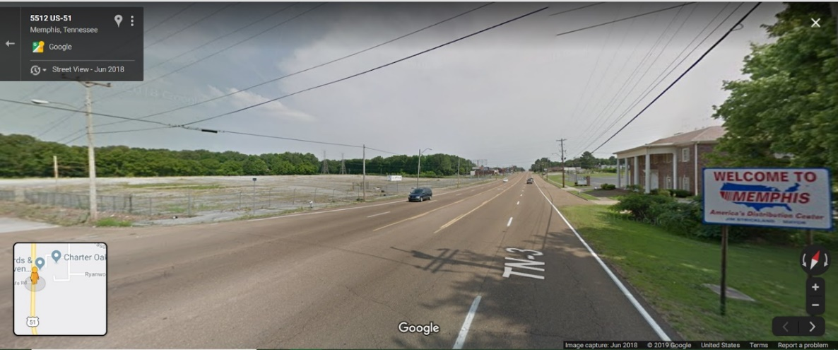
Image 1. Memphis’ abandoned land can be seen upon entering from Mississippi (Google Earth, 2018).
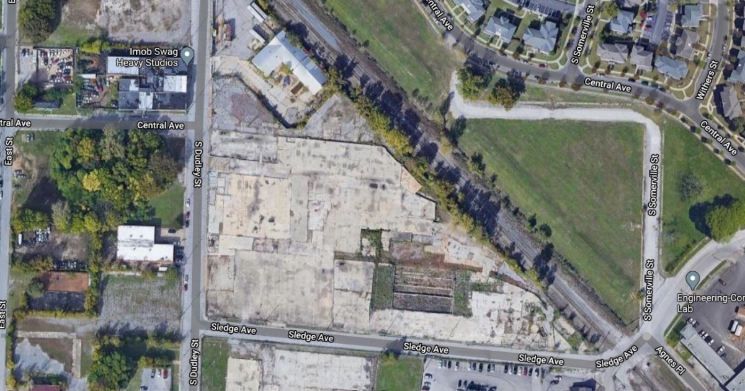
Image 2. Aerial imagery examples of large-scale blight in Memphis, TN 38104.
While parcels have been successfully mapped by the Shelby County Government using zoning and land use codes, current parcel data limits the efficient tracking of blighted properties. Even though there has been a great push for reducing blight in Memphis since 2016, many larger spaces are still laying waste. The Tennessee Department of Environment and Conservation [TDEC] being “committed to providing a cleaner, safer environment that goes hand-in-hand with economic prosperity and increased quality of life” (2019), has mapped the spatial distribution of brownfields across Shelby County, but the program only operates on a voluntary basis, which leaves many parcels of land unaccounted for. While other entities such as the Land Bank and Blight Authority of Memphis also work to repurpose vacant properties, the process is slow. The amount of urban blight is extensive but not organized in a standardized way, currently there is no way to solely identify blighted or vacant parcels using zoning and land use attributes. ReGIS 2019 parcel data does not specify through categorical coding whether abandoned structures are on site if the property is listed as ‘vacant’ – there is no way to confirm if a vacant parcel is in fact blighted. Parcels coded as “0” (which means “Vacant”) and zoned as Industrial and Commercial (CMU-1, CMU-2, CMU-3, CBD, MU, EMP, WD, OG, IH) were used for preliminary mapping, however, current spatial data for Shelby County inaccurately depicts blight in all its forms.
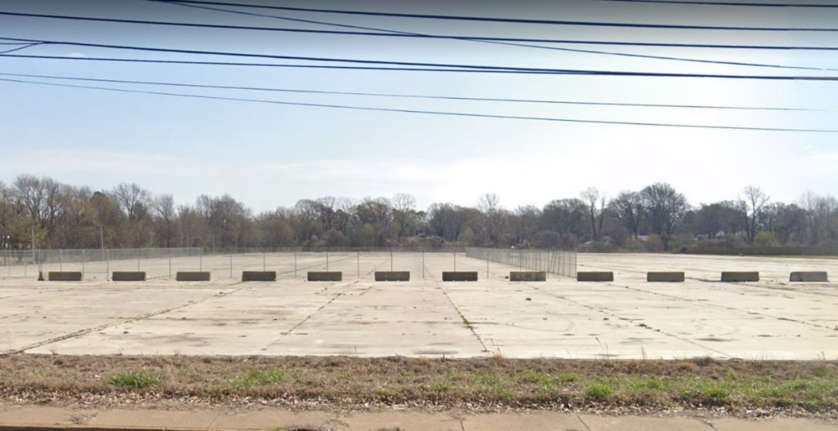
Image 3. Aerial imagery examples of large-scale blight in Memphis, TN 38107
It is difficult to map blight in Shelby County with the current available coding, however I have located many sites which I have confirmed to be abandoned industrial or commercial space through aerial and physical surveying. The current map of blight is not entirely accurate, I had firsthand experience with this data through Innovate Memphis (2020). Many blighted homes and larger properties are not included in the official map shared on the local news. (https://www.wmcactionnews5.com/2019/11/01/searchable-memphis-blight-map/).
Importance
People are in fact shaped by their environment because everything is connected. It is important that Shelby County prioritizes the remediation of blight, especially close proximity to youth, neighborhoods, and schools. What must be kept in mind is the importance of future generation’s health and success. The way young people experience nature has an influence on their life. An environment filled with abandonment and danger is not beneficial to Shelby County residents, while an environment filled with greenspaces is beneficial. Significant historical events have driven many properties to vacancy and complicated legalities make it difficult to find and hold property owners accountable for blight. Every property has its own story and requires understanding to craft a strategy to move forward.
This year 29 children have been murdered as of November 2020, according to Fox 13 local news. (11/9/2020) Memphis’ violence is the result of deep rooted issues that plague its communities. (A few days later the number reached 30.) The police chief interviewed stated: We have to restore spaces for our kids and give them pathways to avoid the pitfalls of violent crime, guns, drugs, gangs, and academic failure. He suggested adopting schools in an effort to refocus on what really causes crime. It is clear that based on statistics, SC has problems with crime, poverty, and school failure. Many societal problems SC faces are connected to one major factor and that is the built environment – the way land is being used, and our relationship with the environment. News as of March 2021 addressed the ‘pandemic of violence’ in Memphis. The violence can be connected to high amounts of blight.
It is important that youth have a way to connect with nature. Multiple national and international studies have concluded that violent behavior, attention span, creativity, fatigue, and depression in youth are influenced by time spent playing outdoors, in open green spaces near trees (Louv, 2008). Other studies on mental disorders such as bipolar disorder, ADHD, and physical disabilities such as childhood obesity, have shown these problems to be increasing as more youth spend less time outdoors (Rigolon & Flohr, 2014). According to Lee (2015) “Greater benefits are associated with larger green spaces, as larger spaces draw in more physical activity or exercise.” Therefore, an emphasis is made on identifying large sites near schools. Factors such as distance are key in determining the placement of large green spaces, with “optimal distance being about 0.5 miles from a school or neighborhood” for optimal use (Lee, 2015). I hope that by locating large blighted spaces nearest to youth, light is shed on the need for youth-to-nature corridors. Methods for reducing blight and revival through greening are growing concepts, as studies show environmental benefits to greening include improved air quality, reduced urban heat island effects, improves permeability for ground water. In addition, exposure to green spaces enhances social health, even leading to higher educational success rates in youth (Kuo et al. 2018).
Methodology
To answer my research questions, I develop an analytic of youth to nature disconnect across Shelby County, using methods which can be applied in urban settings to assesses features of the built environment. Using objective measures such as remote sensing and GIS, existing features that hinder youths’ connection to parks, greenways, or urban gardens / nature, are identified by their greyness. My method includes aerial surveying as well as analysis of census statistics to justify the list showing each housing district’s youth-to-nature disconnect. Initial mapping of large-scale blight sites was accomplished using parcel data from the Regional GIS Department of Shelby County (ReGIS). Further research and physical surveying locate youth most vulnerable to disconnection due to aspects of their built environment. I use blight proximity to schools and surrounding neighborhood walkability to understand how likely youth are able to connect with nature in the area. School locations are used as anchor points within housing districts in order to investigate features that surrounding youth may experience in the built environment.
To perform more analyses, GIS tools are used to discover the distances between schools and green space. I include the “WalkScore” website’s calculate walkability using their formula, which takes crime data into account but not the presence of blight. To measure distances and investigate Shelby County’s urban form, analyses were ran using Arcmap tools such as Utility Network Analysis tool: Find Disconnected, or Proximity Analysis, Corridors, Euclidean distance, Nearest-Neighbor, and the Connectivity GIS tool.
The study is designed to pinpoint certain neighborhoods, to perform more in depth comparison analyses between housing districts based on the identified barriers across each neighborhood code, zip code, census tract, and housing district. Areas are compared based on mapping of population density, greenways, schools, blight, and parks using data from PolicyMap and ReGIS (2019). Particular neighborhoods and zip codes within housing districts which are most vulnerable can then be identified.
Public Safety: | Health: | Infrastructure: | Education: | Economic Environment:
Incarceration, Crime rate | Walkability,  Park presence,  Proximity to Industrial Polluting facility | 1+ acre Blight presence, Vacant Housing Units | School presence | Poverty level
Table 1. Variables that are grouped accordingly.
Public safety, health, infrastructure, education, and economic environment are variables typically used in quality-of-life studies, which I modeled from. Each variable will be measured using GIS and census data statistics.
Data included in mapping:

Shelby County Parcels
Census tracts
Land Use/Zoning
Population density
Greenway/Greenline
Greenspaces/parks
Urban Gardens (Tilth)
Roads
Bike paths
Housing Districts
Vacant housing units
Housing in Poor Condition
Schools
Socioeconomics
Polluting Industrial facilities

Findings
Shelby County, TN has very high amounts of large-scale blight in areas of high youth population density. Housing district 11 (zip code 38118) has the highest amount of youth with high amounts of blight and low park presence. Youth are most vulnerable when the environment is as follows:
High presence of blight
School 0.5 mile buffer containing blight
Low walkability
High number of vacant housing units
High crime or incarceration
High poverty
Low park availability
Low bike path availability
Low greenway/greenline access
Close proximity to polluting industrial facilities
When comparing maps of youth population density on PolicyMap, it was noted that in all age groups: 0-4, 5-9, 5-17, 10-14, 15-17, Under 18, the areas with the highest percentage of youth are within Housing district 11, with 4, 6, and 7 being second highest. Statistics for the age group 0-4 are shown below. This age group was chosen in order to evaluate the environment babies are being born into. As children grow up in these blighted areas, they become more likely to experience negative social outcomes and have a lower quality of life.

Neighborhood | Zip code |  | %Youth | Blight Acreage | Housing District
Old Hickory Hills | 38116 | 6.87% |  | 3,109 | 11
Kirby Trace | 38119 | 6.14% |  | 1,340 | 13
Orange Mound | 38114 | 7.27% |  | 738 | 10
Whitehaven / Westwood | 38109 | 5.76% |  | 642 | 9
East Memphis / Colonial Acres | 38117 | 8% |  | 601 | 13
Parkway Village / Oakhaven | 38118 | 10.36% |  | 294 | 11
Bartlett Woods | 38134 | 6.97% |  | 273 | 6
South Memphis / Longview Heights | 38106 | 7.05% |  | 267 | 10
North Memphis / New Chicago | 38107 | 5.90% |  | 185 | 7
Frayser | 38127 | 9.99% |  | 184 | 7
Normal Station / Sherwood Forest | 38111 | 6.52% |  | 173 | 13
Midtown / Cooper Young | 38104 | 4.24% |  | 121 | 10
Country Wood | 38016 | 6.45% |  | 104 | 1
Table 2. The above table shows where the highest amounts of large-scale blight are located, the associated neighborhoods, housing district and their estimated percent of all people age 0-4, between 2015-2019.

The table shows that the highest amounts in acreage of large-scale blight (1+ acres) can be found in one of the highest youth population density zip codes, where 3,109 acres of land is zoned vacant industrial or commercial, and 6.87% of the population are babies. Too many children are growing up in blighted communities, where crime rates poverty, littering and illness are higher, school performance is lower, access to fresh and nutritious food is lower, park presence is lower, job availability and housing values are lower, and all this takes a toll on the livelihood of future generations. The soil, air and water quality are also threatened by lack of toxic waste cleanup, abandoned concrete, metals, and other pollutants left from industrial or commercial use.

Further investigation of socioeconomic statistics using data from PolyMap revealed the influence blight has at the census tract level. Youth who go to school where there is large-scale blight within a half mile radius are more likely to witness vacant housing and poverty in their neighborhood. The below table shows that schools containing large-scale blight within a half mile radius are in census tracts that experience low home values, higher incarceration rates, and where less people obtain higher education.
School Environment (0.5 mile radius & associated Census Tract) | Vacant Housing Units | Median Home Value | Population Under 18 | Incarceration Rate, low income families | Families Living in Poverty | People with less than high school diploma
[00] Contains Neither | 180 | $163,654 | 25.55% | 3.23% | 16.50% | 12.48%
[01] Contains Park | 189 | $176,352 | 24.50% | 2.51% | 13.49% | 10.65%
[10] Contains Vacant | 325 | $96,521 | 25.99% | 4.07% | 26.16% | 18.16%
[11] Contains Both | 275 | $85,038 | 23.36% | 4.52% | 26.06% | 19.35%
Table 3. For census tracts containing more than one school with differing buffer analysis outcomes, the mode outcome was used to categorize the tract. All school locations were further investigated through Google Earth to confirm whether a park or vacant parcel was in fact within the half mile buffer.
The below map shows which large-scale blight parcels are closest to youth. Those census tracts, shown as a blue star, are highlighted yellow. When layered onto the housing districts, it can be noted that district 11 has the most concentrated large-scale blight near youth.
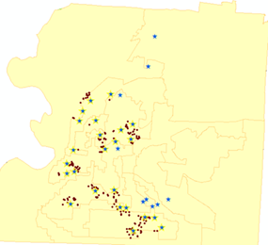
Figure 1. Borders showing housing districts. Blue stars indicate census tracts with high youth (under age 5) population density, highlighted are those containing large-scale (1+ acre) blight: shown in red dots.
It is important to note that school environments with large-scale blight within a half mile radius also contained the highest amounts of housing blight – this shows how devastating large-scale blight is for a community, and how blight spreads like a cancer. In some neighborhoods entire blocks of houses are abandoned, and illegal dumping is common – this influences youths’ perception of their environment and its value. The historical significance of neighboring areas could be preserved in a plan that utilized blight sites for greenspaces and park systems planning. Below are images taken in summer of 2020, while physically surveying blighted properties.
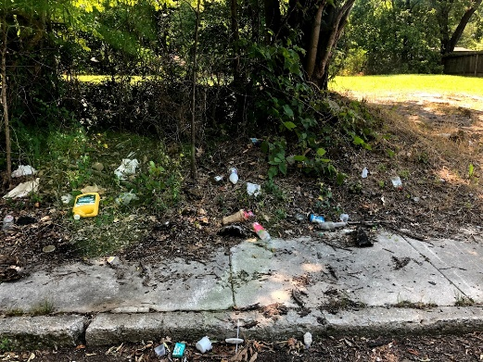 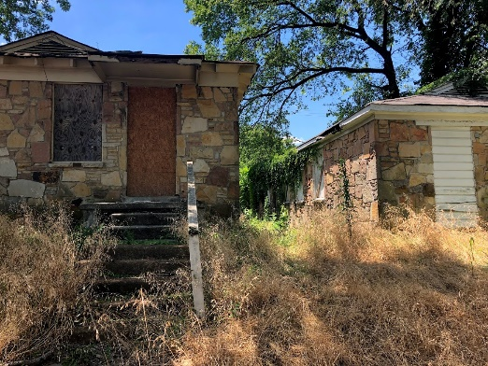
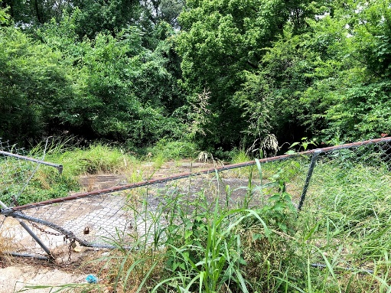 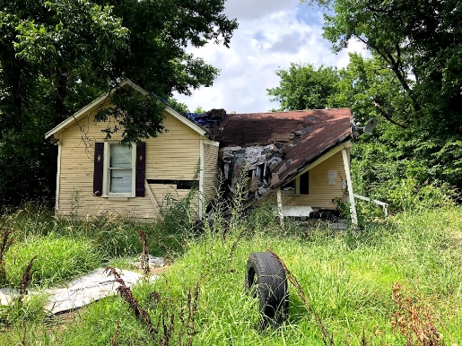
Image 4, 5, 6, 7. Commercial and residential blight in South Memphis, 2020.
Larger sites pose a greater problem that is most sustainably remedied through greening. Using phytoremediation techniques to remediate the land is a practice that could be applied to the current GreenPrint Plan or Memphis Regional Canopy Plan. The presence of blight in all its forms hinders the environment, makes it less walkable and less safe for youth. The city of Memphis alone has a Walk Score of 36 and Bike Score of 44, which are low according to Walkscore (2020). School environments containing large-scale blight should be the top priority for remediation since youth tend to walk around their schools and a half mile is a walkable distance. Large-scale blight being this near to any school is hazardous and the result of zoning issues or misuse of land.
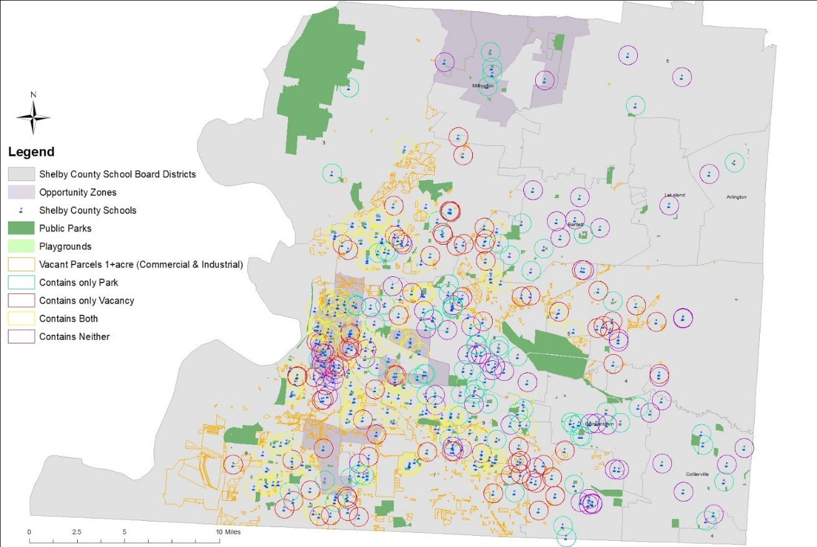
Figure 2. Schools are shown with half mile buffers. Red buffers indicate schools that have large-scale blight nearby.
The above map reveals the shape of each large-scale blight parcel, along with the shape of each park, and what every K-12 Shelby County School contains within their 0.5 mile radius. In addition, two prime examples of large-scale blight within a half mile radius to a school and neighborhood are shown below. These two sites, one being in North Memphis and the other in South Memphis, if remediated to greenspace, could create new corridors to existing greenline access points.

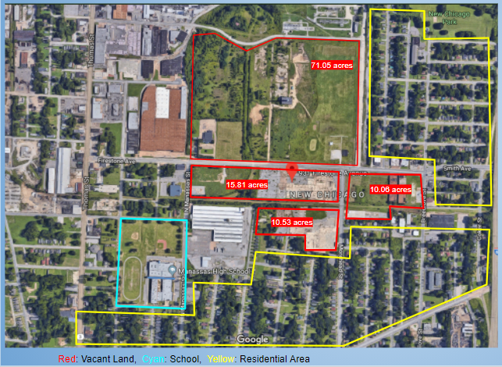
Abandoned Industrial Site
931 Firestone Ave. Memphis, TN 38107 (107.45 acres)
within 0.5 mile from Manassas High School: rated C- by Niche.com, 2018
- Residential area has a median home value of $39K
- Block Group Vacancy 32.5%
- Block Group Poverty 25%
- Walkability 35%
- No Public Transit stop
- Food Desert
- 0.49 miles from 100-500 Year Flood Zone, FEMA

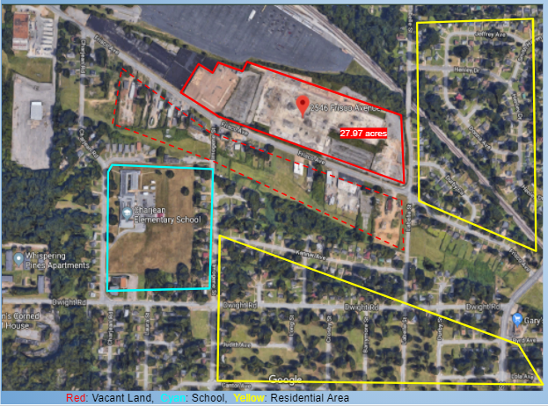
Abandoned Industrial Site
2546 Frisco Ave. Memphis, TN 38114
(27.97 acres) *most buildings/businesses in between site and residential area are BLIGHTED / abandoned as well
Within 0.5 mile from Charjean Elementary School: rated C- by Niche.com 2018
- Block Group Median Home Value of $49.7K
- Block Group Vacancy 27.3%
- Block Group Poverty 44%
- Walkability 25%
- No Public Transit stop
- 0.84 miles from 100-500 Year Flood Zone, FEMA

Image 8, 9. Aerial imagery of large-scale industrial blight sites near schools and neighborhoods in North and South Memphis.
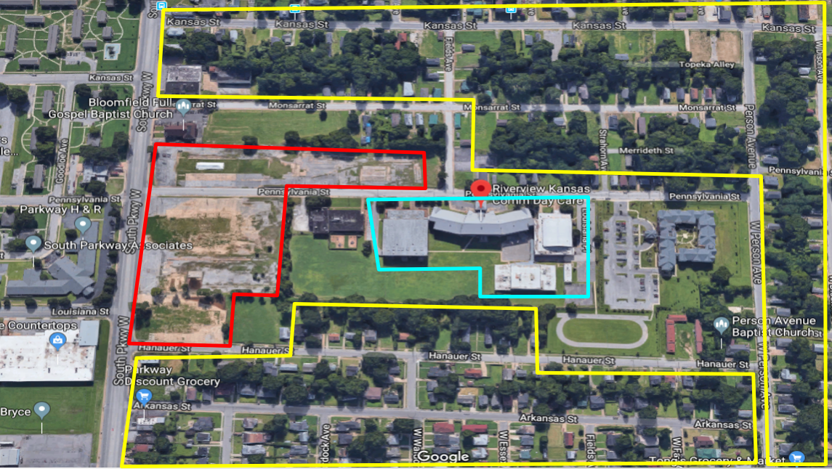
Image 10. Example of large-scale commercial blight near school in Mound Bayou / Soulsville
165 South Parkway West, Memphis, TN 38109
Adjacent to Riverview Kansas Elementary School and Memphis Scholars Middle School
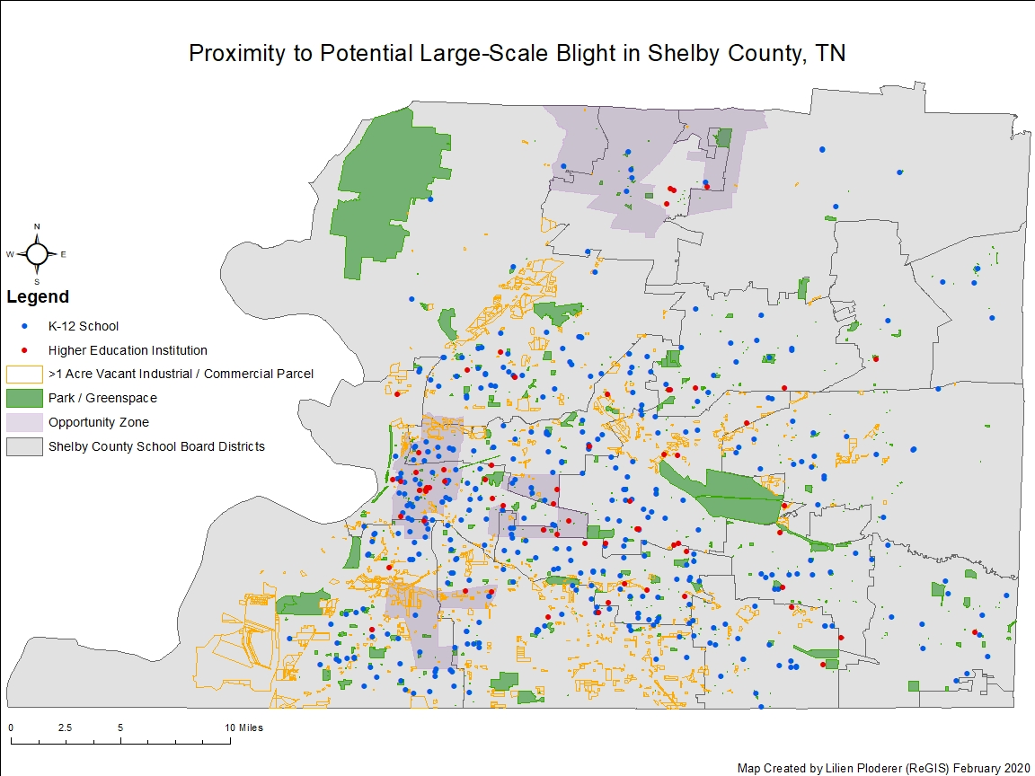
Figure 3. The geography of large-scale blight in proximity to school and existing greenspaces.
Further mapping to identify barriers for youth revealed that district 11 is disconnected to the greenline, the area contains several polluting industrial facilities, low park availability, and fewer bike paths. The railways were included in this map to show how industrial and commercial blight are typically situated along these old routes. Such blighted routes are in need of remediation and offer a connection to existing greenlines and a means of space for park systems planning.
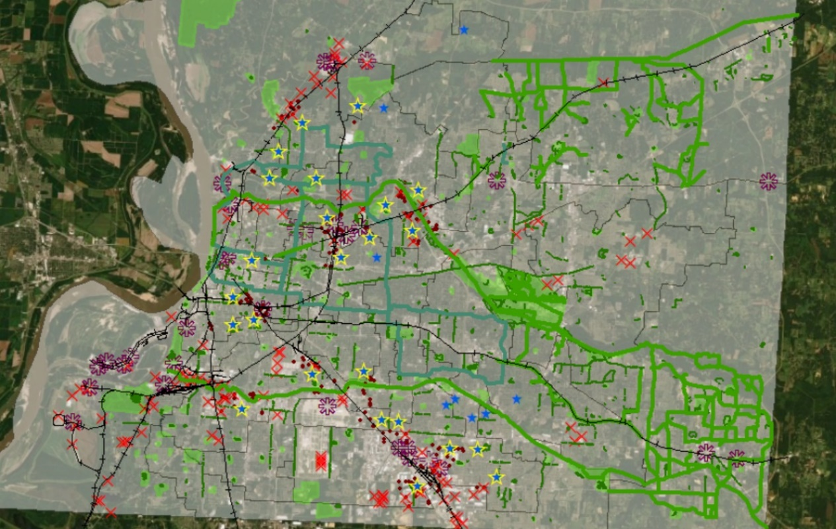
Figure 4. Shown are existing greenways, the greenline, bike paths, greenspaces. Black lines are railways. Dark purple asterisks mark a major industrial polluting facility. Red x’s are large-scale blight points and the dark red rots are large-scale blight points within census tracts containing a high youth population density.
When searching for new corridors to open for youth-to-nature engagement, the best possible locations are in South and North Memphis. Southeast of the Memphis International Airport, this area is burdened with heavy industrial pollution and commercial vacancy but still has a high youth population density compared to other areas with higher amounts of greenspace.
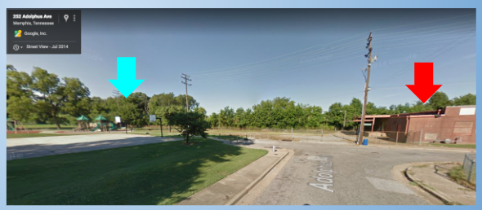
Image 11. Blight adjacent to school and playground in South Memphis, 1.7 miles from Stax Museum of American Soul Music. This space could be reused as an extension of the playground for sports or recreation for the surrounding community.
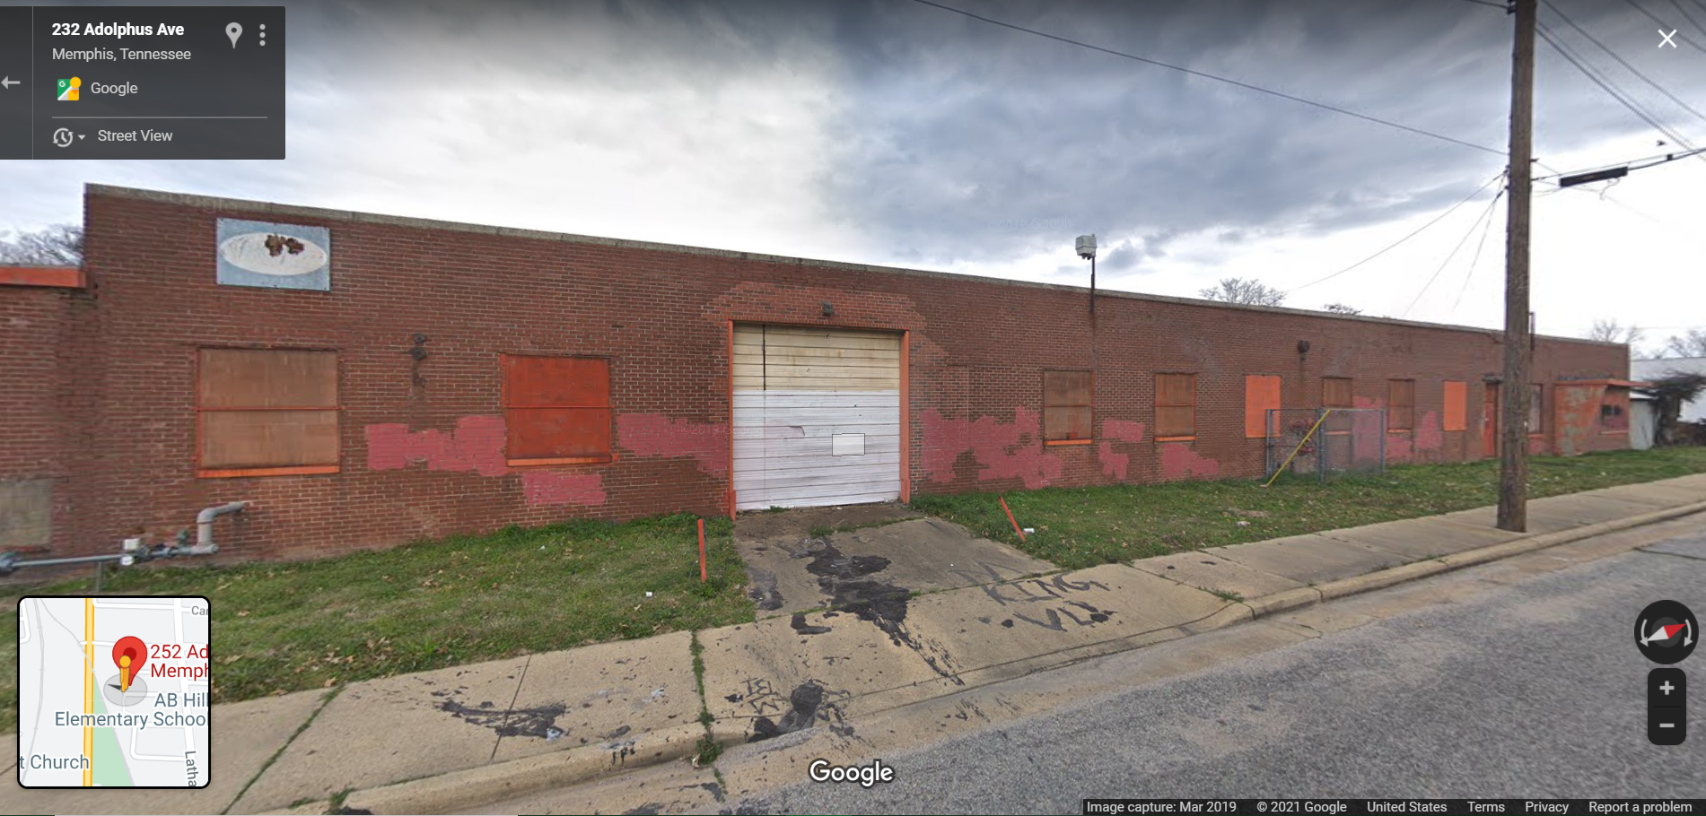
Image 12. Example of commercial blight across the street from a playground in South Memphis zip code 38106.
Youth in their early stages of child development are likely to see such sites as they are near to schools and neighborhoods with high youth population density aged under 5, and youth under 18. Large blighted buildings near playgrounds pose as significant barriers to nature engagement.
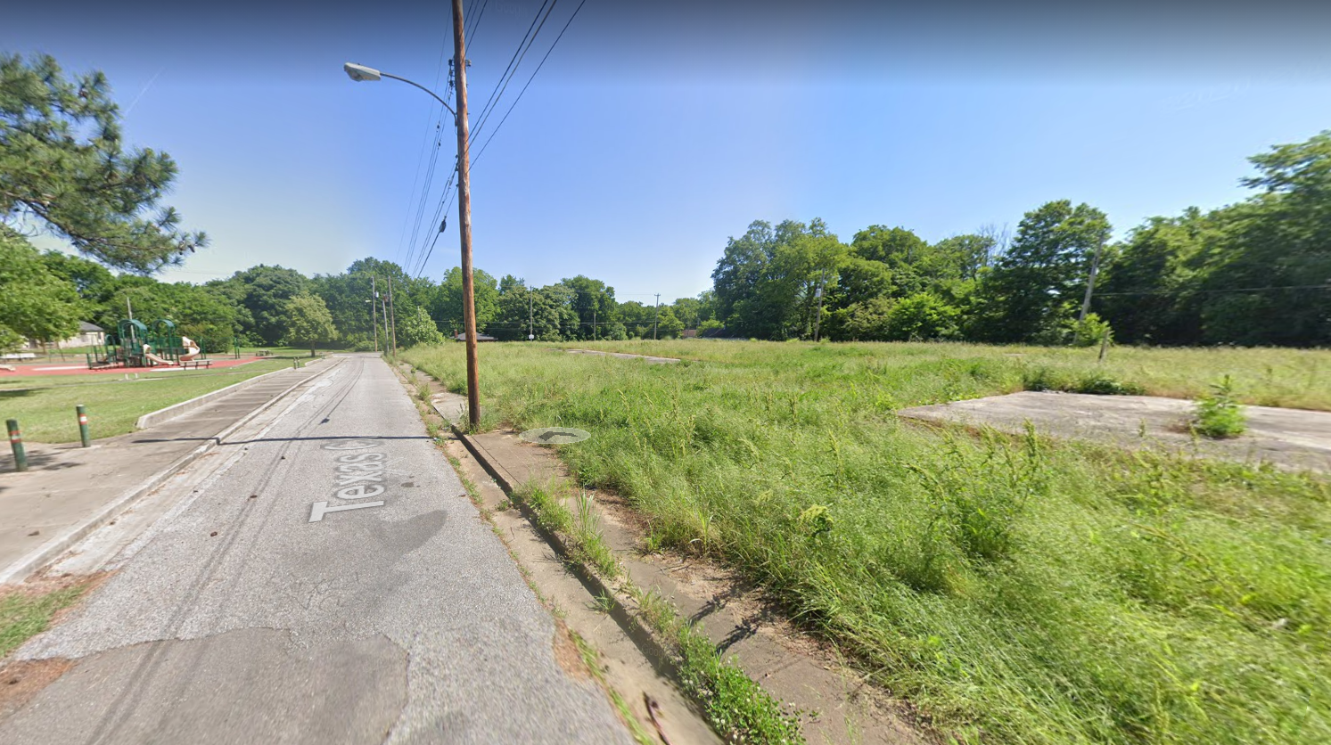
Image 13. Another example of commercial blight across the street from a playground in South Memphis, 38106. This location would be a nice location for an urban garden that the whole neighborhood could utilize.

The final map below depicts large-scale blight sites and their acreage, along with all the existing corridors of bike paths, greenlines and parks in areas with high youth population density.
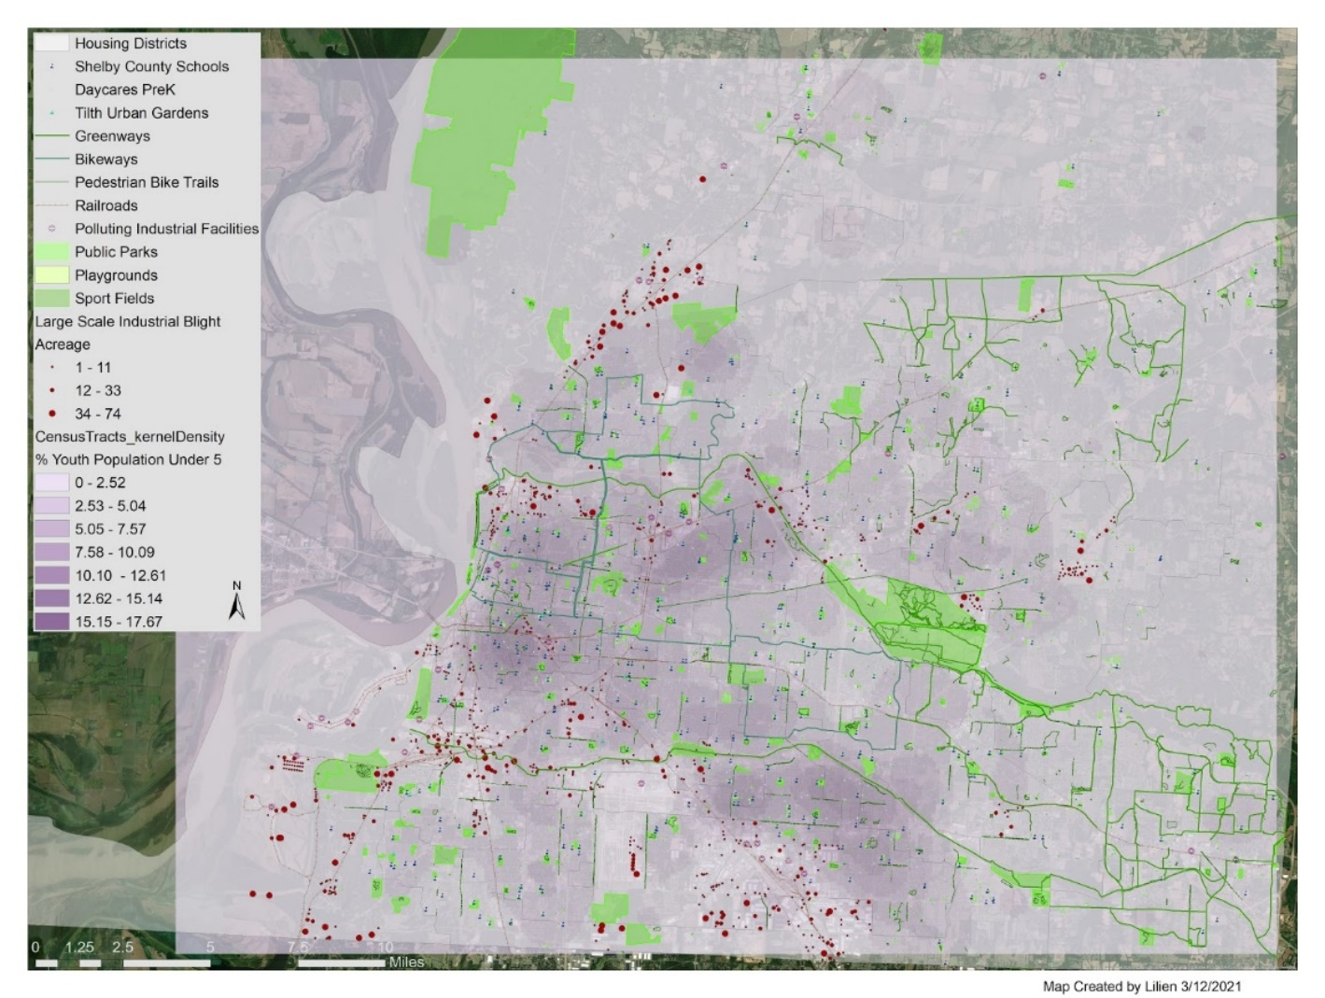
Figure 5. This kernel density overlay map shows where the youth population under age 5 is most dense, the darker the purple the more young children reside per census tract within each housing district across Shelby County, TN.

Large-scale blight, along with smaller blight under 1 acre in size are causing major disconnects between youth and nature. Many sites situated along the existing greenways could also serve as greenspaces to form a connected park system. Once larger blight is eradicated, smaller scale such as residential blight will be easier to tackle. Greenspaces have so many positive benefits and in a post Covid society where people are less interested in being in crowded, poorly ventilated rooms, open space areas will be in demand. This type of community investment would be the most beneficial for Shelby County.
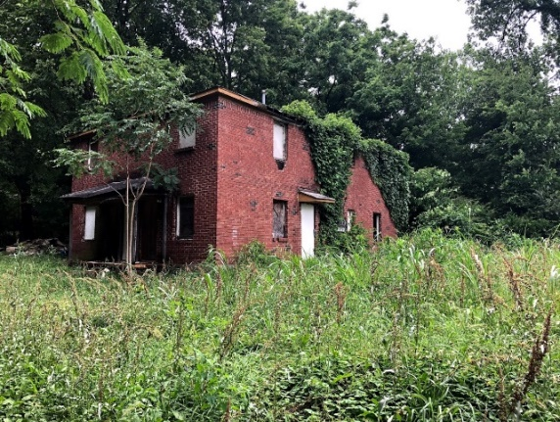 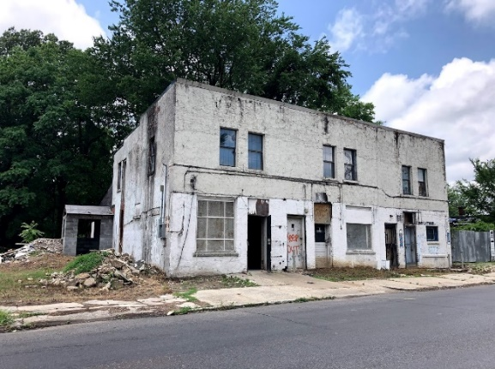
Image 14, 15. Examples of blight - 2 acre large parcels of commercial vacancy in South Memphis neighborhoods, 38106.
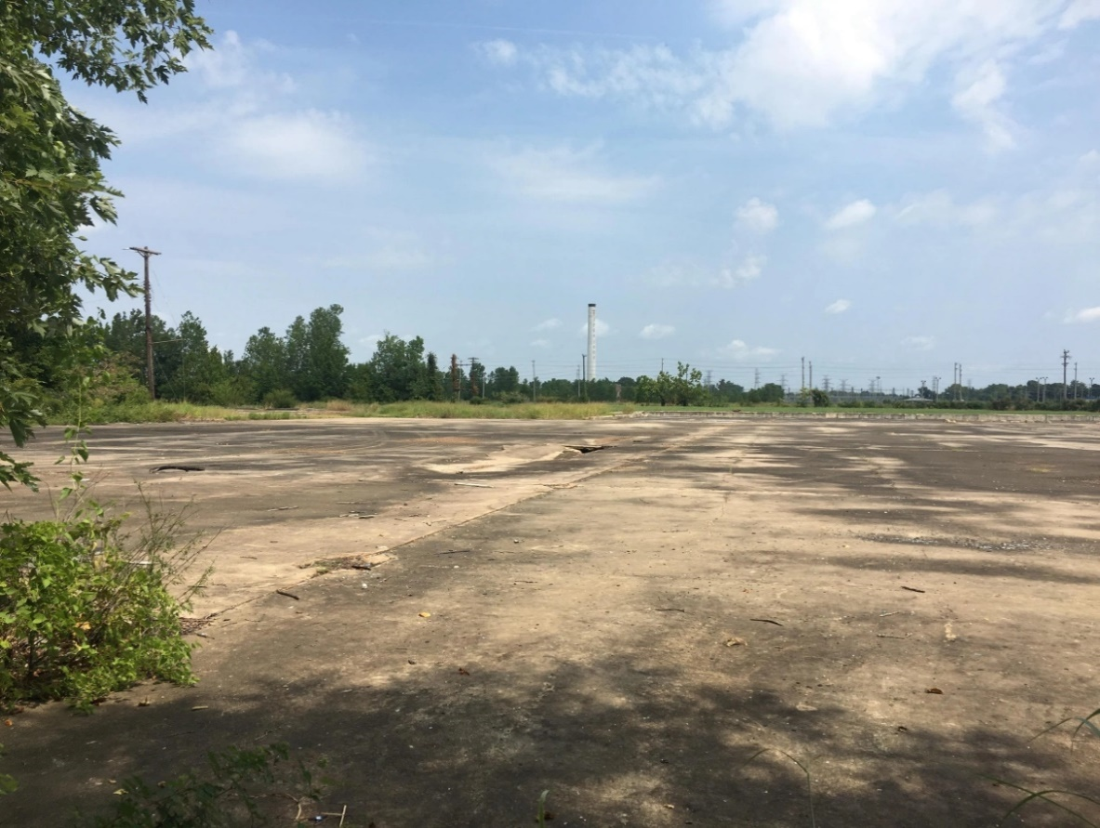
Image 16. Large empty lot near a blighted neighborhood in North Memphis, Ayers Street 38107.
After going out to physically survey many of these vacant industrial and commercial sites, I have found that many would greatly benefit the community if they were remediated into greenspaces. The urban environments near schools shows a lot about a community and has an impact on the success of that neighborhood.

Conclusion
Shelby County youth are likely to experience blight in their daily lives. Based on 2019 parcel data, 24.5% of K-12 schools contain only large-scale blight within a half mile radius. Only 21% of schools contain a park within a half mile radius. Remediation is key, sustainable solutions such as greening near schools are the best and highest use for larger sites of blighted land. Final outcomes of the study are as follows:
Blighted industrial properties are concentrated in North Memphis and South Memphis,
(Zip Codes: 38106, 38107, 38114, 38116, 38118). The average size of blighted industrial properties within Memphis is 6.2 acres. Quarter-mile buffer around blighted industrial properties in Memphis identified 49 schools within walking distance. Half-mile buffer around K-12 schools identified 92 contained only large-scale blight, 79 contained only a park, 75 contained neither, and 129 contained both out of 375 schools total. Residential areas and schools are in close proximity to blighted industrial properties in inner city locations. I observed low median home values and C- school ratings for all schools with nearby blight, and in many cases these schools were also in food desserts. Site-specific socio-economic statistics show possible correlation of blight with degraded neighborhood quality, including public transit access and walkability.
The census tracts with the highest amounts of housing blight were within the housing districts
6, 7, 9, 10, 11. Most census tracts containing high-density youth population, experience 3-6 acres of blight within 1 mile from their centroid, and at least 5 sites are an average of 0.5 miles away from another.

Current spatial data for Shelby County inaccurately depicts blight in all its forms, this is why my study focused on mapping blight as accurately as possible nearest to schools. My paper alone cannot solve the problems many residents face, however greenspace development is possible with regional and local leadership support. The remediation of blight is an ongoing issue that will require vision, time, community engagement, and focused funding.
Are there places that could be enhanced by reducing blight and creating safe greenspaces nearest to youth populations in Shelby County?
Yes, located on the southeast side of the Memphis International Airport - blight concentrations and proximity to pollution are highest near to youth under age 5 in this area. One prime example is 2546 Frisco Avenue site, which is near the University of Memphis – this abandoned site could be transformed into a greenspace that the nearby school and neighborhood could use.
· Which areas in Memphis are most disconnected from greenways and greenspaces?
South Memphis is the most disconnected from greenways, with high youth population density in high blight, high crime, and high poverty, near industrial polluting sites. There are fewer bike paths and access points to greenways and few large community parks, besides T.O. State Fuller Park to the Southwest.
· Where are SC’s largest blighted spaces? Which ones are closest to youth populations, schools or residential zones?
The largest blighted spaces nearest to youth are in North Memphis - where the largest parcel nearest to a school is over 100 acres (931 Firestone Avenue 38107), which is in housing district 8. Other severe large blighted sites that are near to schools are concentrated in South Memphis, area code 38103, housing district 9.
· How can SC “design with nature” and utilize blight in the process?
Major remediation projects within South Memphis near the airport and Graceland, towards Orange Mound are areas that need new corridors for youth-to-nature engagement. The Nonconnah Creek in this area could act as a means to design with nature by locating sites that may be within flood zones or aquifer recharge areas and would greatly benefit from phytoremediation. Enhancing the environment is connected to future stability.
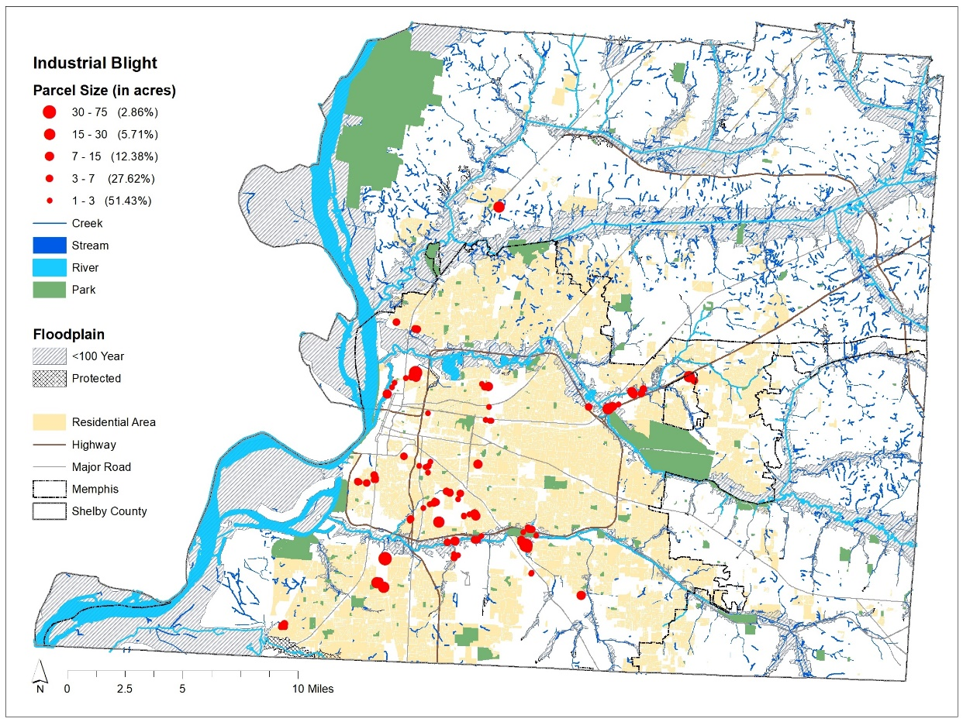
Figure 6. Extra mapping of 100 year floodplains and large-scale industrial blight sites shows that many are located near the Nonconnah Creek in South Memphis. Existing greenspaces near large-scale blight can be incorporated into a future park system, leading to T.O. Fuller State Park and Martin Luther King Jr. Riverside Park in South Memphis.
Youth in Shelby County are in need of more ways to connect with nature and feel safe in their environment, rather than go far outside of their community to experience a park. Unfortunately, there is fear in walking due to broken glass, concrete and blighted, off-limits buildings scattered around. Without prioritizing the remediation of blight, cities face environmental challenges, such as air quality issues, excess heat capture, polluted stormwater runoff, and less ecological biodiversity (Knizhnik, 2012). A parks system that utilizes blight is possible. Socioeconomic statistics can prove that blight has a negative impact at the census tract, zip code, or housing district level, while park presence has a positive impact. The environment around schools is an opportune space in communities for creating commodities that support youth-to-nature engagement. While many schools further east are connected to greenlines and greenways, more schools could be connected via new corridors.

References
American Planning Association. (2019). Standards for Outdoor Recreational Areas. Retrieved from
https://www.planning.org/pas/reports/report194.htm
Anderson, E. C., & Minor, E. S. (2017). Vacant lots: An underexplored resource for ecological and social benefits in cities.
Urban Forestry & Urban Greening, 21 , 146-152. doi:10.1016/j.ufug.2016.11.015
Akpinar, A., Barbosa-Leiker, C., & Brooks, K. R. (2016). Does green space matter? Exploring
relationships between green space type and health indicators. Urban Forestry & Urban Greening, 20, 407-418.
doi:10.1016/j.ufug.2016.10.013
Barth, D. (2020). Parks and Recreation System Planning: A new approach for creating
sustainable, resilient communities.
Borden, Kevin & Schmidtlein, Mathew & Emrich, Chris & Piegorsch, Walter & Cutter, Susan. (2007). Vulnerability of U.S.
Cities to Environmental Hazards. Journal of Homeland Security and Emergency Management. 4. 10.2202/1547-
7355.1279.
Branas, C. C., South, E., Kondo, M. C., Hohl, B. C., Bourgois, P., Wiebe, D. J., &
MacDonald, J. M. (2018). Citywide Cluster Randomized Trial to Restore Blighted Vacant Land and its Effects on Violence, Crime, and Fear. Proceedings of the National Academy of Sciences, 115(12), 2946-2951. doi:10.1073/pnas.1718503115
Branas, C., Kondo, M., Murphy, S., South, E., Polsky, D., & MacDonald, J. (2016, December). Urban Blight Remediation as a
Cost-Beneficial Solution to Firearm Violence. PubMed Central (PMC).
https://www.ncbi.nlm.nih.gov/pmc/articles/PMC5104992/
Chen, S., Christensen, K. M., & Li, S. (2019). A Comparison of Park Access with Park Need
for Children: A Case Study in Cache County, Utah. Landscape and Urban Planning, 187,
119-128. doi:10.1016/j.landurbplan.2019.04.001
de Leon, E. and J. Schilling, 2017. Urban Blight and Public Health. Addressing the Impact of
Substandard Housing, Abandoned Buildings, and Vacant Lots. At:
https://www.urban.org/sites/default/files/publication/89491/2017.04.03_urban_blight_an
d_public_health_vprn_report_finalized.pdf
Esuoso, B. (2017, October 5). Battling Blight in Memphis. Retrieved from
https://prospect.org/article/battling-blight-memphis
Health and Safety - Mid-South Regional Greenprint. (2015). Retrieved from
http://new.midsouthgreenprint.org/greenprint-20152040/strategic-directions/strategic-direction-four/
Hosseini, A., Pourahmada, A., Taeebb, A., Aminic, M., & Behvandid, S. (2017, March). Renewal Strategies and Neighborhood
Participation on Urban Blight. ScienceDirect.com | Science, health and medical journals, full text articles and books.
https://www.sciencedirect.com/science/article/pii/S2212609015300923
Kuo, F. E., & Sullivan, W. C. (2001). Environment and Crime in the Inner City - Does
Vegetation Reduce Crime? Environment and Behavior,33(3), 343-367. doi:10.1177/0013916501333002
Kuo, M., Browning, M. H., Sachdeva, S., Lee, K., & Westphal, L. (2018). Might School
Performance Grow on Trees? Examining the Link Between “Greenness” and Academic Achievement in Urban,
High-Poverty Schools. Frontiers in Psychology. https://doi.org/10.3389/fpsyg.2018.01669
Louv, R. (2008). Last Child in the Woods: Saving Our Children From Nature-Deficit Disorder.
Chapel Hill, NC: Algonquin Books
Manlun, Yang. (2003). Suitability Analysis of Urban Green Space System Based on GIS.
International Institute for Geo-information Science and Earth Observation.
https://webapps.itc.utwente.nl/librarywww/papers_2003/msc/upla/yang_manlun.pdf
Rigolon, Alessandro & Flohr, Travis. (2014). Access to Parks for Youth as an Environmental Justice Issue: Access Inequalities
and Possible Solutions. Buildings. 4. 69-94. 10.3390/buildings4020069.
Rundle, A. G., Chen, Y., Quinn, J. W., Rahai, N., Bartley, K., Mooney, S. J., Bader, M. D., Zeleniuch-Jacquotte, A., Lovasi, G.
S., & Neckerman, K. M. (2019). Development of a Neighborhood Walkability Index for Studying Neighborhood
Physical Activity Contexts in Communities across the U.S. over the Past Three Decades. Journal of Urban Health,
96(4), 583–590. https://doi-org.ezproxy.memphis.edu/10.1007/s11524-019-00370-4
Sandra Albro. (2019). Vacant to Vibrant : Creating Successful Green Infrastructure Networks. Island Press.
Shelby County Housing Districts. (2001). Shelby County, TN - Official Website | Official
Website. https://www.shelbycountytn.gov/DocumentCenter/View/21644/County-
Commission-District-and-Precinct-Map-with-Streets_201507200921327821?bidId=
Song, Y., Kirkwood, N., Maksimović, Č, Zhen, X., Oconnor, D., Jin, Y., & Hou, D. (2019).
Nature based solutions for contaminated land remediation and brownfield redevelopment in cities: A review. Science of The Total Environment, 663, 568-579.
doi:10.1016/j.scitotenv.2019.01.347
Talen, E., Menozzi, S., & Schaefer, C. (2015). What is a “Great Neighborhood”? An Analysis of APA’s Top-Rated Places.
Journal of the American Planning Association, 81(2), 121–141. https://doi.org/10.1080/01944363.2015.1067573
WalkScore (2020) https://www.walkscore.com/TN/Memphis
Wong, Q. W. (2017, August 23). Urban Blight. Public Health Post. https://www.publichealthpost.org/research/urban-blight/

